PRN – 260245920034

- Display the Employee Name, Job, and Start Date of Employees hired from February 1981 to May 1981.
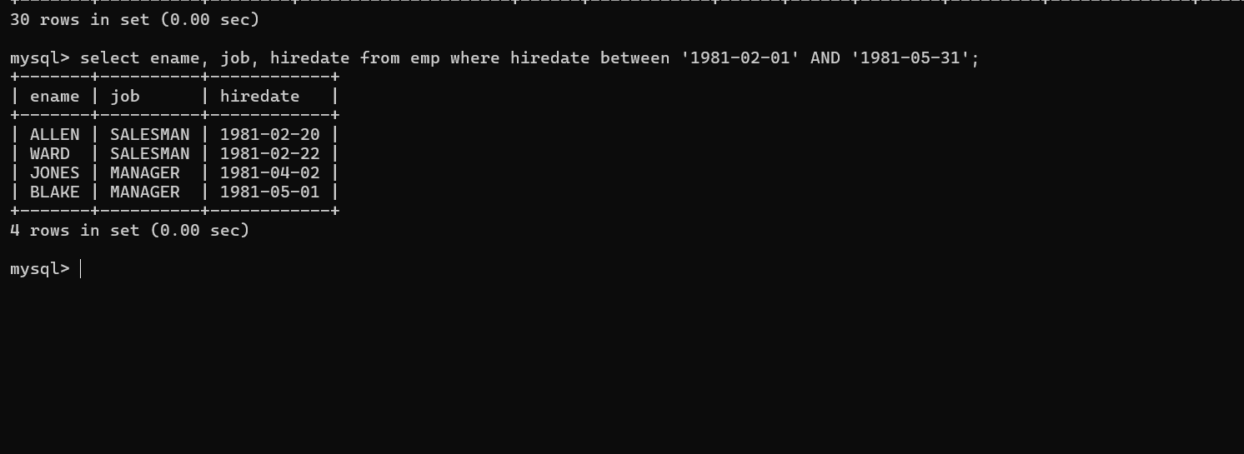
mysql> select ename, job, hiredate from emp where hiredate between '1981-02-01' AND '1981-05-31';

- Display the Name and Hiredate of every Employee who was hired in 1982.
mysql> select ename, hiredate from emp where year(hiredate) = 1982;
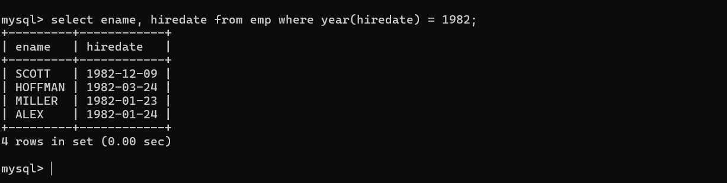
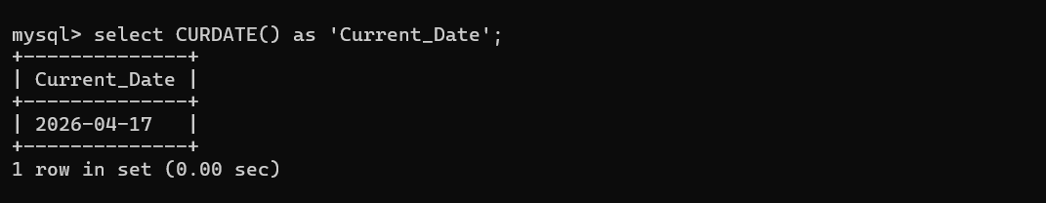
- Write a query to display the current date. Label the column as Current Date.
mysql> select CURDATE() as 'Current_Date';

- Display the Employee’s Name, Hiredate, Salary and Review Date, which is first Monday after six months of service.
SELECT ename,
hiredate,
sal AS Salary,
DATE_ADD(
DATE_ADD(hiredate, INTERVAL 6 MONTH),
INTERVAL ( (7 - WEEKDAY(DATE_ADD(hiredate, INTERVAL 6 MONTH))) % 7 ) DAY
) AS Review_Date
FROM emp;
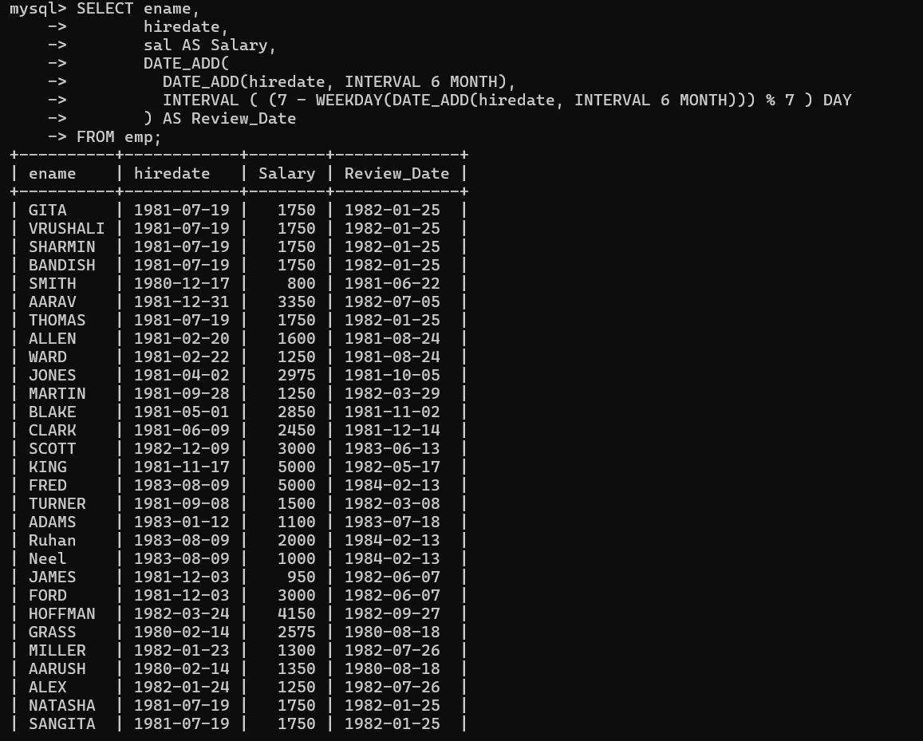

- Modify the query to display the dates as “Sunday, the Seventh of September, 1981”.
SELECT ename,
hiredate,
sal AS Salary,
DATE_FORMAT(
DATE_ADD(
DATE_ADD(hiredate, INTERVAL 6 MONTH),
INTERVAL ( (7 - WEEKDAY(DATE_ADD(hiredate, INTERVAL 6 MONTH))) % 7 ) DAY
),
'%W, the %D of %M, %Y'
) AS Review_Date
FROM emp;
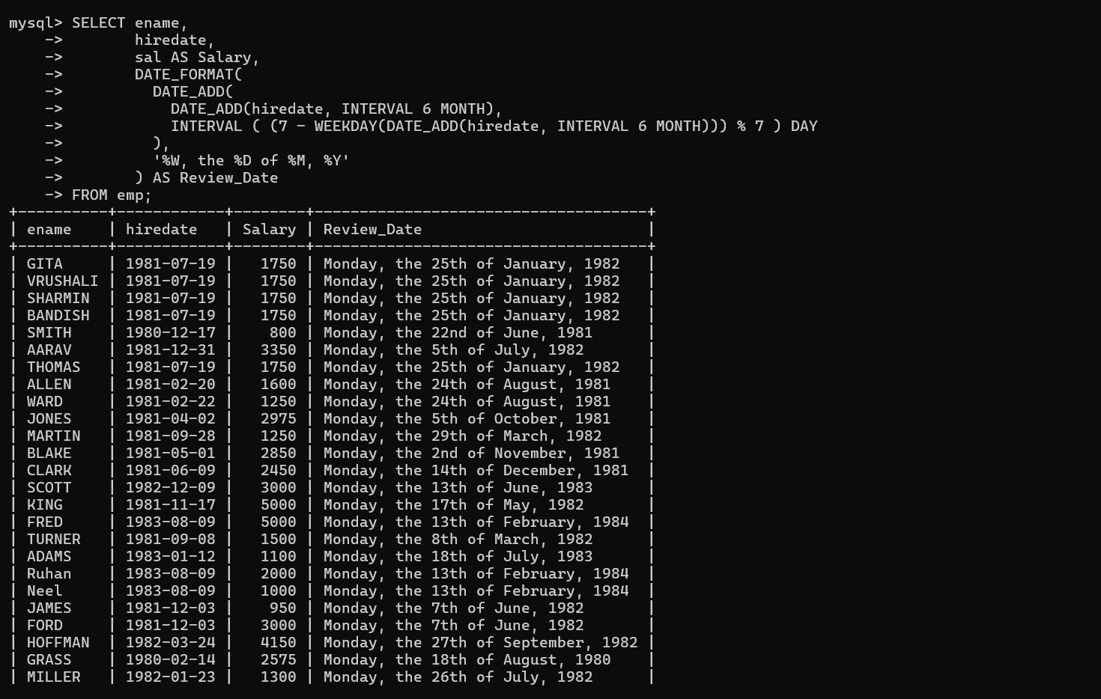

- Create a query to display the name and salary for all Employees. Format the salary to be 15 characters long by adding ‘$’.

SELECT ename,
LPAD(CONCAT('$', sal), 15, ' ') AS Formatted_Salary
FROM emp;
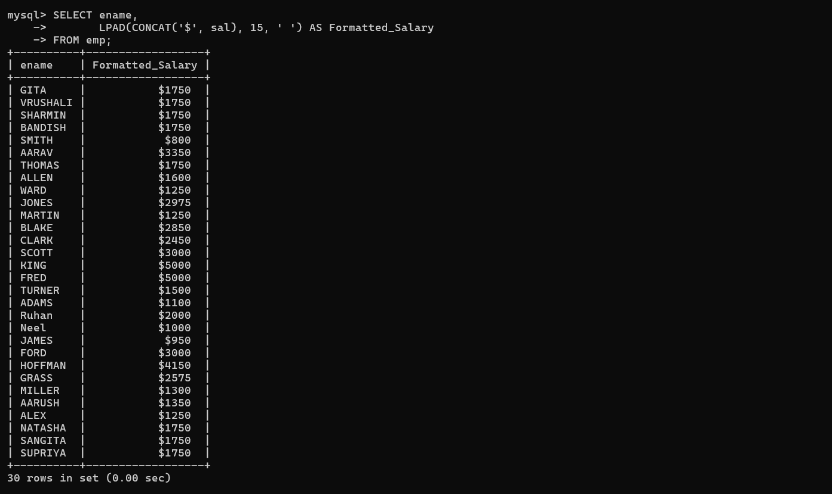
- Display the Name, Hiredate and day of the week on which the employees started. Order the results by the Day of the week starting with Monday.

SELECT ename,
hiredate,
DAYNAME(hiredate) AS Start_Day
FROM emp
ORDER BY WEEKDAY(hiredate);
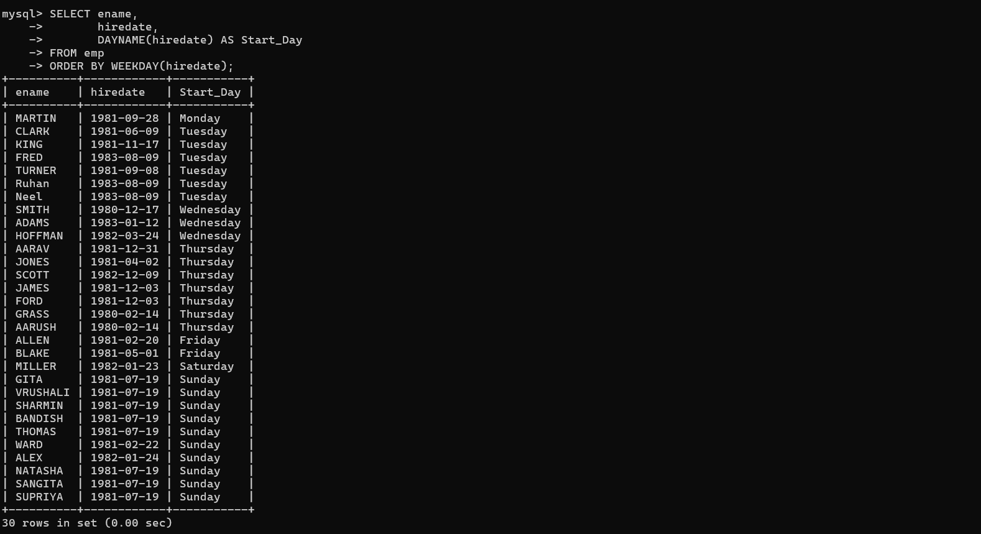

- Display details of orders received in the year 1986.

mysql> select * from orders where year(odate) = 1996;
//1986

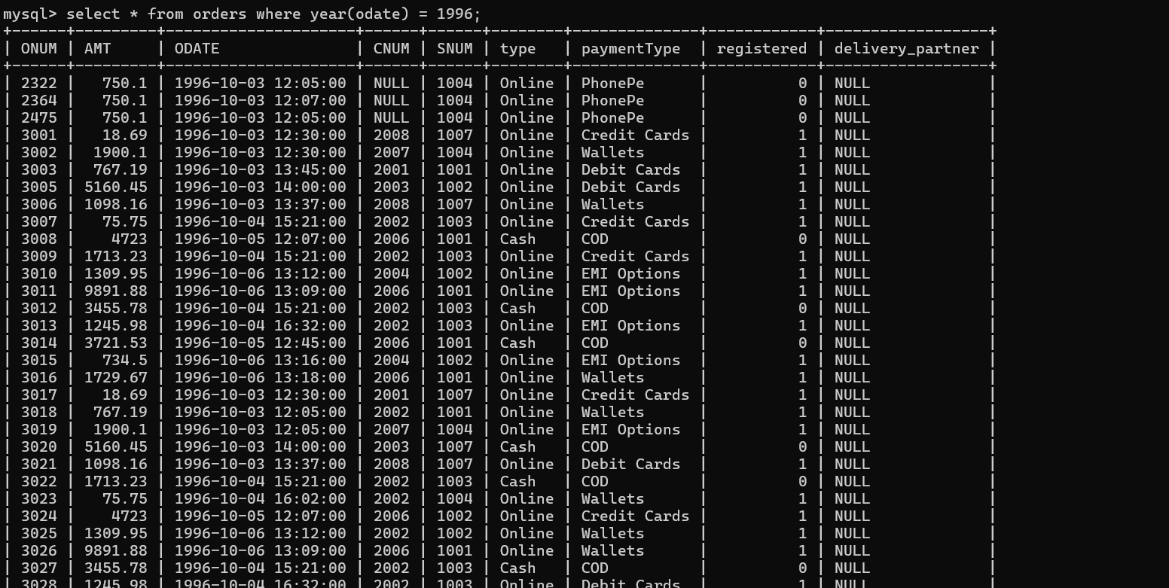

- Write a query to find out the DAY (for example, SUNDAY) of the current date.

mysql> SELECT DAYNAME(CURDATE()) AS Current_Day;
+-------------+
| Current_Day |
+-------------+
| Friday |
+-------------+
1 row in set (0.00 sec)

- Display the name and the date of joining of the employees who belong to department number 10. The date of joining should be formatted. For eg. if it is ‘10-JUN-97’ it should be displayed as Fifteenth JUNE, 1997. The name of the employee should be in upper case.
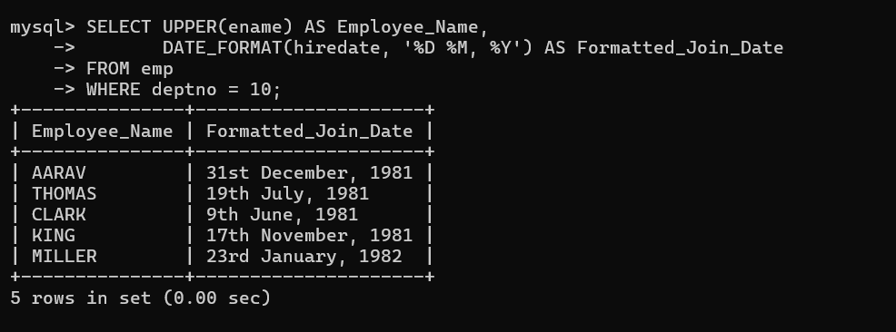

- Consider the Ord table. Find the difference between the Order Date and Ship Date in months as well as days. Label the columns appropriately.

- List employee details who have joined in December.

- Display day on which KING joined.
- Display month on which MARTIN joined.
- Find number of days elapsed between today’s date and hiredate of ‘ADAMS’.
- Print the date, 15 days alter today’s date.
- List all employee hired in the month of December.
- List all employee hired after 1980.
- Display names and jobs of employee in the format SMITH-CLERK.
- Show the length of names in EMP table. Eliminate duplicate length. Do not show the names.
- List the names and hiredate of EMP in dept 20, display hiredate formatted as 12/03/1984.
- Find the day of week on which SMITH joined.
- Retrieve the ANALYST record with hiredate formatted as ‘The 3rd of Oct. 1984’.
- Calculate the total compensation expensive for each dept in 1 year. Assume that employees, who don't earn commission, receive non-monetary benefits than are worth Rs.1000 a month.
- Display the Names of the Managers as follows-
- If the employee code is 7788 the Manager is CLARK
- If the employee code is 7698 the Manager is BLAKE
- If the employee code is 7566 the Manager is JONES
- For all other Employees the Manager is KING

